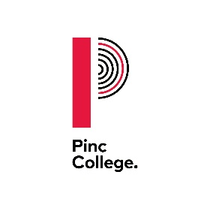

**Date 1st July 2024**

Dear Parents/Carers,

**Free College Meals for the academic year 2024 to 2025**

I am writing to tell you how Pinc College implement the Department for Education Policy in relation to free College meals.

For the 2024 to 2025 academic year the rate set is £2.53 per student per meal taken. The meal is provided for the days where a student attends College over the lunchtime period or is on an external work-placement.

If your child was already receiving a free meal at their school or College on or after 1 April 2018, they will continue to be entitled to receive a free meal in College for 2024-2025. This applies even if your household earnings have risen above the Universal Credit thresholds. All students over the age of 19 must also have an Education Health and Care Plan.

Please provide a copy of any previous entitlement letters to the College, where available. Alternatively the College will ask your previous learning provider or your home local authority to provide confirmation of your eligibility.

If you wish to apply for a free College meal for the first time in 2024-2025 you must complete an application form. The application process requires students and/or parents and carers to provide evidence of benefits that they are receiving.

Please contact the College if you would like to discuss this further or make an application. Application deadline is Friday 18th October 2024. Please note that our policy is to maintain strict confidentiality in the review and storage of the evidence you provide to us.

Yours sincerely,

Ben Swallow

Chief Finance and Operations Officer