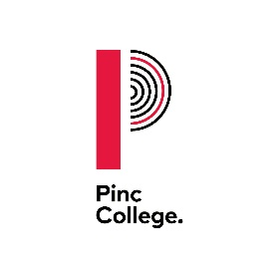

Date 12/09/2023

Dear Parents/Carers,
Free College Meals for the academic year 2023 to 2024
I am writing to tell you how Pinc College implement the Department for Education Policy in relation to free College meals.
For the 2023 to 2024 academic year the rate set is £2.53 per student per meal taken. The meal is provided for the days where a student attends College over the lunchtime period or is on an external work-placement.
If your child was already receiving a free meal at their school or College on or after 1 April 2018, they will continue to be entitled to receive a free meal in College for 2023-2024. This applies even if your household earnings have risen above the Universal Credit thresholds. All students over the age of 19 must also have an Education Health and Care Plan. The College will ask your previous learning provider or your home local authority to provide confirmation of your eligibility.
If you wish to apply for a free College meal for the first time in 2023-2024 you must complete an application form. The application process requires students and/or parents and carers to provide evidence of benefits that they are receiving.
Please contact the College if you would like to discuss this further or make an application. Application deadline is 31st October 2023. Please note that our policy is to maintain strict confidentiality in the review and storage of the evidence you provide to us.

Yours sincerely,

Ben Swallow
Chief Finance and Operations Officer

